Game Design Document

Student Number: 10650690

Game Name: Necrophobia

Table of Contents

* Page 3 – Game Story
  + Page 3 – Section 1: Game backstory
  + Page 3 – Section 2: Character details
* Pages 4 to 6 – Flowcharts/Diagrams
  + Page 4 – Menu flowchart
  + Page 4 – Main menu screen diagram and screen description
  + Page 5 – Game screen diagram and screen description
  + Page 6 – Game Over screen diagram and screen description
* Pages 7 to 8 – Game Elements
  + Page 7 - Player Character
  + Page 8 – Enemies
  + Page 9 – Blocks
* Pages 10 to 13 – Level Design
* Pages 14 – Game Breakdown
* Page 17 to 19 – Press Kit
* Page 20 to 21 – Feedback
* Page 22 – Essential links related to my game

Game Story

Game Backstory

The undead have taken over the world! The death toll has risen exponentially with the manpower of the undead climbing in turn.

Only those who have, so far, staved off the undead with their skills are known by a single label: Survivors.

The Survivors do exactly as their name implies: They survive the undead onslaught using their skills in survival and firearms handling.

However, with each great loss that the undead suffer, their speed, strength and endurance increase in turn, making it harder for the Survivors to handle the onslaught.

Character Details

Name: Survivor

Appearance:



Character backstory:

The player character is playing as a Survivor. This man’s story is the same as other Survivors: Ex-Military or having some kind of connection to the military, hence his knowledge of how to handle weapons; Life uprooted since the apocalypse has begun; He just fights for himself. A Survivor’s mission is simple: Survival first.

Stereotypes:

[Silent Protagonist](https://tvtropes.org/pmwiki/pmwiki.php/Main/HeroicMime?from=Main.SilentProtagonist): Taking cues from popular titles such as DOOM and the Half Life series, the Survivor character was intended to be purely a silent protagonist. There are two reasons for this:

* In-Game explanation: Noise attracts the undead. The guns naturally make noise so there is no choice there. But early Survivors have noted that the silent Survivors are the ones who survive longer due to the fact that there is, relatively speaking, less noise for the undead to listen out for.
* Out-of-Game explanation: I felt that voice lines for a character would have added more effort than I deemed necessary. So, I decided not to go for voice lines and focused purely on the game mechanics.

[Action Hero](https://tvtropes.org/pmwiki/pmwiki.php/Main/ActionHero): He’s a character who uses him combat skills to achieve his own goal, which is, as mentioned earlier, survival. This easily makes him an action hero.

Flowcharts/ Diagrams

Menu Flowchart

Main Menu

Game Level

Game Over Menu

Main Menu screen diagram

Image

Text

Screen Description

Image to display the sprite that contains both the title of the game as well as the tagline of the game

Text to prompt the player to press any button to start the game

Game screen diagram

Slider *1, has Text Component *1 on top of it

Slider *2, has Text Component *2 on top of it

Slider *3, has Text Component *3 on top of it

Text Component *4

Screen Description

Slider *1: Slider to display the current health of the player

Slider *2: Slider to display the amount of amount that the player currently has

Slider *3: Slider to display the amount of XP the player currently has and how far they need to go to level up.

Text *1: Text component to display the current amount of health that the player has vs the max amount of health

Text *2: Text component to display the current amount of ammo that the player has vs the number of magazines that the player currently has

Text *3: Text component to display the current amount of XP that the player currently has vs the amount of XP that they need to obtain before levelling up.

Text *4: Text component to display the player’s current level.

Game Over screen diagram

Text component*1

Text component *2

Text component *3

Screen Description

*1: Title telling the player that this is the game over menu

*2: Text informing the player what level they reached before dying; And also showing them the link to the survey (Alpha build only).

*3: Text prompting the player to press any key to return to the main menu.

Game Elements

Player Character

Graphics

|  |  |
| --- | --- |
| Name | Appearance |
| playerIdle |  |

Settings

|  |  |  |  |
| --- | --- | --- | --- |
| Property | Description | Type | Access modifier used |
| Speed | This variable is used to dictate how fast the player is moving. The default value is 0.25f | Float | Public: My reason for making it public is purely because I usually test my game while in development, and I wanted to be able to alter the movespeed with ease in the Inspector section of the player if I felt that the movespeed was too fast or too slow. |
| currAmmo | This variable is used to store the current amount of ammo being held by the player. The default value is the value is equal to the value of maxAmmo. | Int | Private |
| maxAmmo | This variable is used to store the max amount of ammo a player can have per magazine. The default value is the value of the ammoPerMag variable in the weapon currently equipped by the player. | Int | Private |
| ammoMags | This variable is used to store the amount of ammo magazines that the player currently has. The default value is 10. | Int | Public static: My reason for making this variable public static was so that the playerLevel.cs script can access it to increment the value each time the player levels up. |
| maxHealth | This variable is used to store the maximum health of the player. The default value is 10. | Int | Private |
| currHealth | This variable is used to store the current amount of health of the player. The default value is equal to that of maxHealth. If the value of currHealth reaches 0, the game ends. | Int | Public static: I have made this a public static variable so that the EnemyScript.cs script can access it to subtract the value of damage from the value of currHealth. |
| playerLvl | This variable is used to store the current level of the player. It increments each time the value of xpCurrent exceeds that of xpRequired. The default value is 0. | Int | Public static: My reason for making it public static is so that the EnemyScript.cs script can access it and apply any changes to any new zombies that spawn after the player next levels up, resulting in zombies that get stronger with the player. |
| xpMod | This variable is used to store the value at which the value of xpRequired will multiply by each time the player levels up. The value is 2. | Int | Private |
| xpCurrent | This variable is used to store the current amount of XP that the player has. The default value for this is 0. | Int | Public static: My reason for making it public static is because the method GiveXP was public static as well (the reason for that was so that it could be called in the EnemyScript.cs script each time the value of enemyHP reaches 0, giving the player 250 xp). |

Weapons

Graphics

|  |  |
| --- | --- |
| Weapon name | Graphics |
| M4A1 | Weapon  Bullet |
| UMP45 | Weapon  Bullet |
| Colt M1911 | Weapon  Bullet |
| SPAS-12 | Weapon  Bullet |

Settings (For the weapons, I have used ScriptableObjects so I gave all the variables public access modifiers).

|  |  |  |
| --- | --- | --- |
| Property | Description | Type |
| weaponName | Contains the name of the weapon | String |
| weaponSprite | Contains the sprite of the weapon which shall be displayed onscreen as the sprite of the playerGun gameobject. | Sprite |
| ammoPerMag | Contains the value for how much ammo can be contained for each magazine with each weapon | Int |
| fireDamage | Contains the value for the damage that each weapon can do. | Int |
| weaponType | Contains the enum value of the weapon. This type is important as it affects what bullet types get fired (shotguns fire shells/pellets, and other weapons like SMGs or ARs fire bullets) | enum |
| currentAmmo | Contains value of how much ammo the weapon currently has | Int |

Enemies

Graphics

|  |  |
| --- | --- |
| Name | Appearance |
| zIdle |  |
| zMove1 |  |
| zMove2 |  |

Settings

|  |  |  |
| --- | --- | --- |
| Property | Description | Type |
| moveSpeed | Contains the speed at which the enemy will move. This value increases each time the player levels up. | Float |
| damage | Contains the amount of damage that the enemy will damage to the player. This value increases each time the player levels up. | Int |
| enemyHP | Contains the amount of health that the enemy has. The enemy dies when this value reaches 0. This increases each time the player levels up. | Int |
| attackTime | Contains the amount of time that has to pass before the enemy attacks. This decreases each time the player levels up. | Float |
| currentTime | Contains the current amount of time that has passed, starting from the value of attackTime and decrementing over time. The enemy deals damage to the player when this value reaches 0. | Float |

Blocks

Graphics

|  |  |
| --- | --- |
| Block name | Graphics |
| Computer |  |
| Tree (Forest) |  |
| Tree (Jungle) |  |
| Barrel |  |

Settings

|  |  |  |
| --- | --- | --- |
| Properties | Description | Type |
| None | Just an obstacle to players | - |

Level Design

Note: The map diagrams are not accurate in regard to how the maps will actually turn out in the final product

Tutorial Map

S

S

S

S

P

P-Up

Map info:

Size: 10x, 10y, 0z

Art assets used:

* arenaGround.png (floor)
* walls.png (walls)

Key:

= Enemy Spawn

= Player

= AmmoMag Pickup

P

S

P-Up

Office-based Map

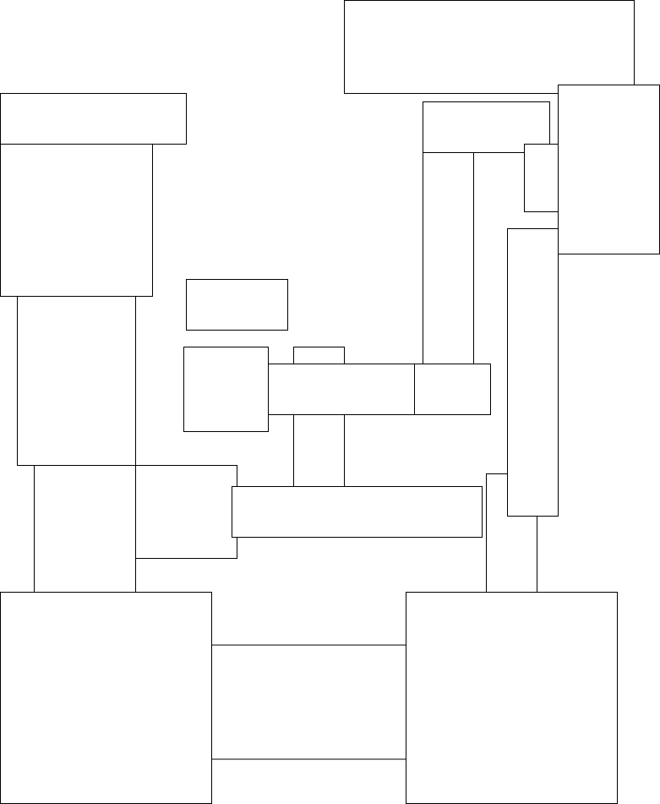

S

S

S

S

S

P-Up

P-Up

P-Up

P-Up

P-Up

P-Up

P

Map info:

Size: 30x, 30y, 0z (estimate)

Art assets used:

* Floor: snowFloor.png, officeFloor.png, wall.png (for garage floor: Admittedly, that was a lazy decision from an artistic angle).
* Walls: officeBuildingWall.png; garageWall.png

Forest-based Map

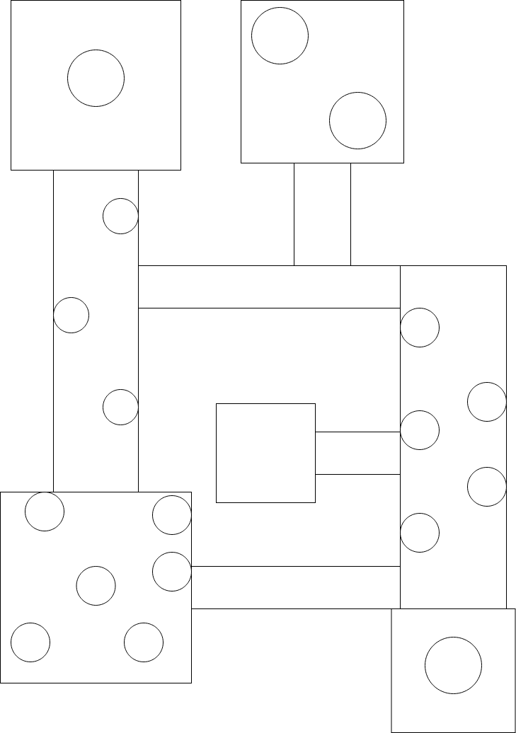

P

S

S

S

S

P-Up

P-Up

P-Up

P-Up

P-Up

Map info:

Size: 30x, 35y, 0z (estimate)

Art assets used:

* Floor: forestFloor.png, shackFloor.png
* Wall: shackWall.png

Jungle-based Map

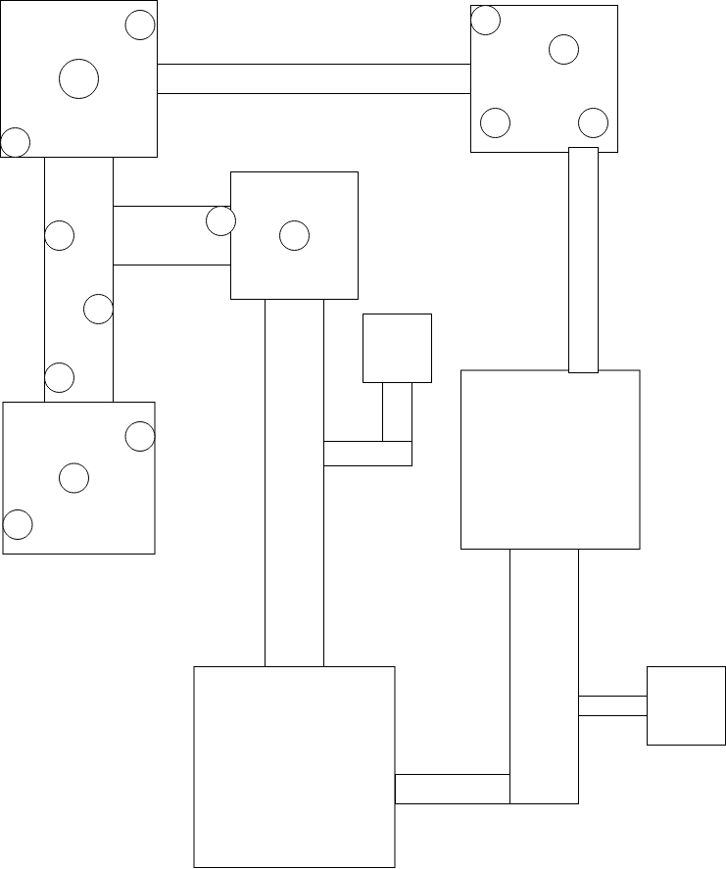

P

S

S

S

S

P-Up

P-Up

P-Up

P-Up

P-Up

P-Up

Map info:

Size: 40x, 45y, 0z (estimate)

Art assets used:

* Floor: jungleFloor.png, bunkerFloor.png
* Wall: bunkerWall.png

Game Breakdown

Game Space

The game space uses a camera that follows the player from a top-down perspective within the map that they have chosen in the Level Selection menu

Game Rules

Player

* Loses health when hit by a zombie
* Loses ammo each time they fire
* Gains XP each time they kill a zombie
* Levels up when they gain enough XP
* Gets an extra ammo magazine when they level up
* Game is over when player loses all health

Bullet

* Dies when it hits a zombie
* Dies after 1.25 seconds

Zombie

* Loses health when hit by a bullet
* Gives player XP when killed
* Becomes stronger each time player levels up

Game Goals

The goal of the game is to gain as high a level as possible before dying.

Game Mechanics

* A movement mechanic which allows the player to move throughout the level.
* A shooting mechanic which gives the player the ability to kill zombies by shooting bullets at them.
* A reloading mechanic which allows the player to replenish their ammo if they have enough ammo.
* An XP/Level-Up mechanic: The player gets XP from each zombie killed, levelling up if they gain enough XP. Each time they level up, they gain an extra ammo magazine.
* A level scaling mechanic: Every time the player levels up, each new zombie possesses stronger stats.

Ingame Controls

* Keys
  + W: Move up
  + S: Move down
  + A: Move left
  + D: Move right
  + R: Reload
  + Q: Switch weapons backwards along the weapon collection
  + E: Switch weapons forwards along the weapon collection
* Mouse
  + Cursor: Look at mouse position
  + Left click: Fire weapon

Press Kit

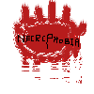Store Icon/Logo

Core features

* Top-down gameplay
* Ability to choose from 4 different maps
* Ability to use 4 different weapons to defeat the undead
* Ability to gain XP for each zombie killed and level up when player has enough XP
* Extra layer of challenge as zombies become stronger each time you level up

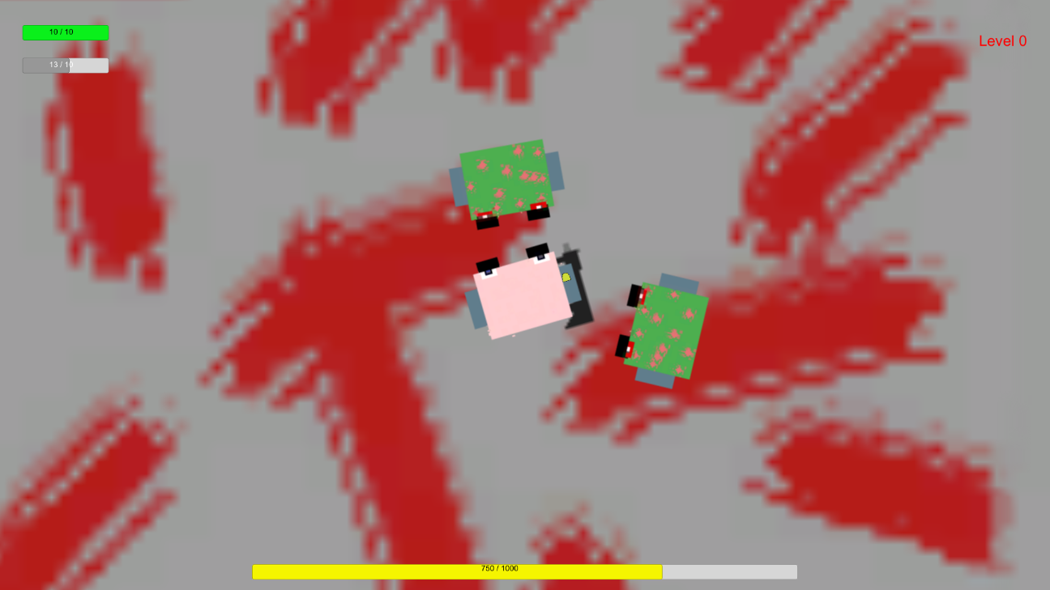Screenshots

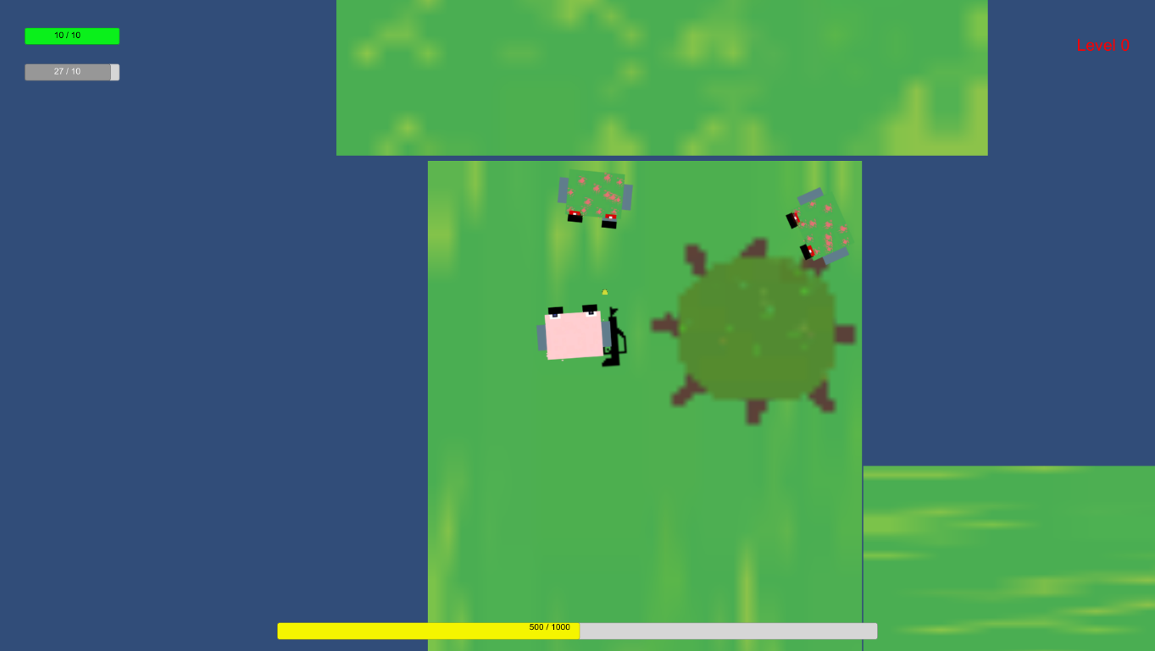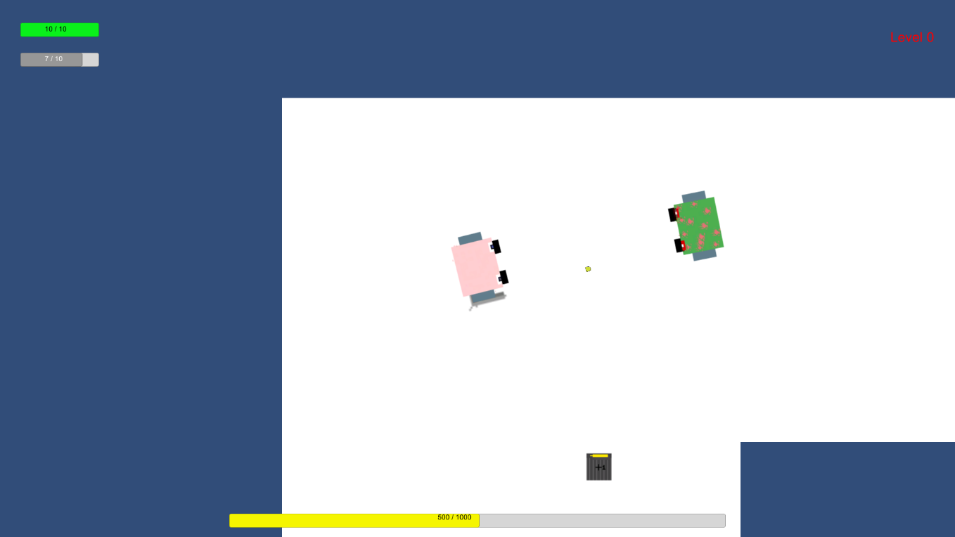

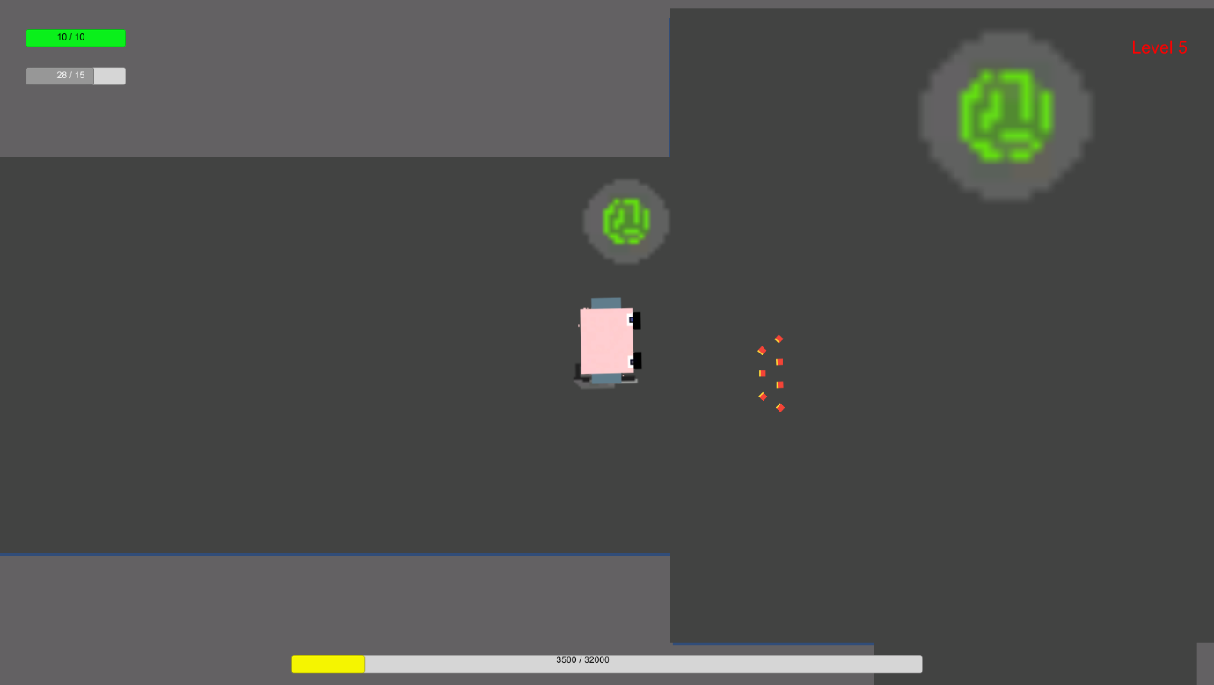

Rating



Similar games

* Call of Duty: World at War – Nazi Zombies
  + Game link: <https://store.steampowered.com/app/10090/Call_of_Duty_World_at_War/>
  + Description of similar features:
    - Shooter gameplay (Firing, reloading, etc)
    - Survival against an infinite amount of zombies
    - Points gained from zombies
* SAS: Zombie Assault 4
  + Game link: <https://store.steampowered.com/app/678800/SAS_Zombie_Assault_4/>
  + Description of similar features:
    - Shooter gameplay
    - Top-down perspective
    - XP/Level-Up system

Feedback

The content of this section of the Game Design Document has been copy-pasted from <https://docs.google.com/spreadsheets/d/1OvzVSK7IARSaQsICQ5FVJboG25AlxQdzH35s7uN-Vys/edit#gid=1980041167> (the feedback and review responses spreadsheet for Part 1 of Demo or Die)

Demo or Die Part 1

Review 1:

The demo functions with no issues to prevent you from playing. The menu is simplistic but works without issue. A tutorial is present when you start the game and helps you understand the basic controls of the game. The waves work and the game gets harder as you progress. Some features I would add would be feedback when I attack the monsters e.g. Blood or knockback. Maybe the level changes slightly as you progress into further waves. Pick ups e.g. Health, ammo types or weapons would make for a more intereting experience.

Review 2:

The controls feel awkward at times as the direction the player moves from an a row input changes with their rotation. The custom style looks good and the leveling up over time is a nice mechanic

Review 3:

I like the sprites you've made for the game, as well as a clear wave/exp system. The map collision at the edge of the screens work well, and the faded effect really adds emphasis to the eerie nature of a zombie shooter. The player moves fairly slow, so perhaps yoiu could add collectibles like health packs or achievement medals? Powerups too, maybe!

Review 4:

The health bar doesn't obviously reflect the damage you take from zombies. Am I even taking damage at level 1? You should also include some kind of feedback from when the zombie hits you to make it more obvious that you are taking damage. You have included a text box showing the controls, consider adding a tutorial to learn the controls interactively instead. The zombie movement seems weird, as if they're jumping around. The bullets go through zombies, if this is intentional, you should make it obvious that a zombie has actually been hit by a bullet (whether they flash a different colour or something for example). Other than that, the game does function, I like the levelling system you have implemented.

Review 5:

TANK CONTROLS Afahighaduigadihaduoigbaduoghadioghd. No. Never. Ammo system seems solid, character moves very slow though.

Summary based on the Demo or Die part 1 feedback:

* XP/Level-Up system is well received
* Player movement is slow
* Pick-Ups would add to the game: I have implemented ammo magazines throughout the maps that players can pick up via colliding into them.

Demo or Die Part 2

Essential links:

Github Repo 1 (covers up to v1.55): <https://github.com/TemperateEnd/2D-unity>

Github Repo 2 (covers up to v3): https://github.com/TemperateEnd/2D-unity-V2

Itch.io: <https://reece-tarrant.itch.io/necrophobia>